Problem 0 : Part B (15 mins):

Iterating with JSON object’s Values
Above is some information about my car. As you can see, I am not the best driver.
I have caused a few accidents.
Please update this driving record so that I can feel better about my driving skills.
CODE:
var myCar = {
make: "Bugatti",
model: "Bugatti La Voiture Noire",
year: 2019,
accidents: [
{
date: "3/15/2019",
damage_points: "5000",
atFaultForAccident: true
},
{
date: "7/4/2022",
damage_points: "2200",
atFaultForAccident: true
},
{
date: "6/22/2021",
damage_points: "7900",
atFaultForAccident: true
}
]
}
//Loop over the accidents array. Change atFaultForAccident from true to false.
//Print the dated of my accidents
for(var i = 0;i<myCar.accidents.length;i++){
myCar.accidents[i].atFaultForAccident = false
console.log("Acc Date : " + myCar.accidents[i].date)
}
console.log(myCar)
Output:
Acc Date : 3/15/2019
Acc Date : 7/4/2022
Acc Date : 6/22/2021
{ make: 'Bugatti',
model: 'Bugatti La Voiture Noire',
year: 2019,
accidents:
[ { date: '3/15/2019',
damage_points: '5000',
atFaultForAccident: false },
{ date: '7/4/2022',
damage_points: '2200',
atFaultForAccident: false },
{ date: '6/22/2021',
damage_points: '7900',
atFaultForAccident: false } ] }

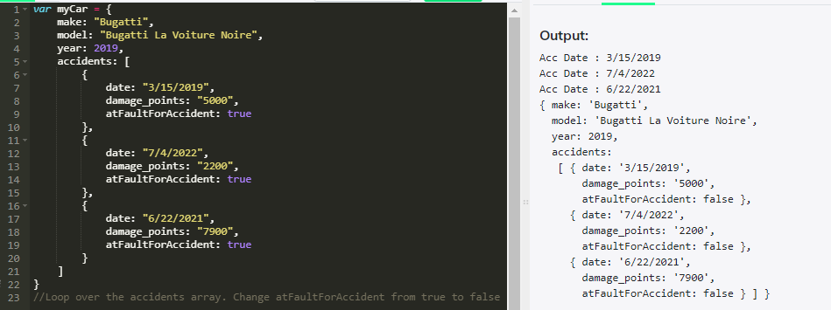

Problem 1 (5 mins):
Parsing an JSON object’s Values:
Write a function called “printAllValues” which returns an newArray of all the input object’s values.

CODE:
var obj = {name : "RajiniKanth", age : 33, hasPets : false};
function printAllValues(obj) {
console.log(Object.values(obj))
}
printAllValues(obj)

Output:
[ 'RajiniKanth', 33, false ]

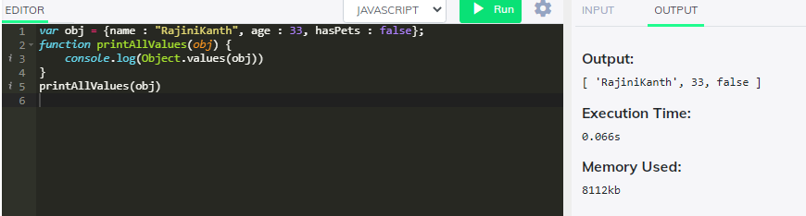

Problem 2(5 mins) :
Parsing an JSON object’s Keys:
Write a function called “printAllKeys” which returns an newArray of all the input object’s keys.

Code:
var obj = {name : "RajiniKanth", age : 33, hasPets : false};
function printAllKeys(obj) {
console.log(Object.keys(obj))
}
printAllKeys(obj);

Output:

[ 'name', 'age', 'hasPets' ]

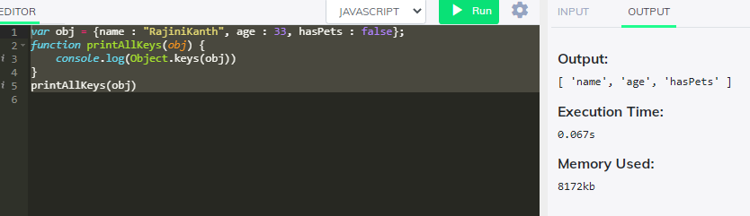
Problem 3( 7–9 mins):
Parsing an JSON object and convert it to a list:
Write a function called “convertObjectToList” which converts an object literal into an array of arrays.
Code:

let obj = {name: "ISRO", age: 35, role: "Scientist"};
let arr = []
function convertListToObject(obj) {
Keys = Object.keys(obj)
for(var i=0;i<Keys.length;i++){
arr.push([Keys[i],obj[Keys[i]]])
}
console.log(arr)
}

convertListToObject(obj)
Output:
[ [ 'name', 'ISRO' ], [ 'age', 35 ], [ 'role', 'Scientist' ] ]

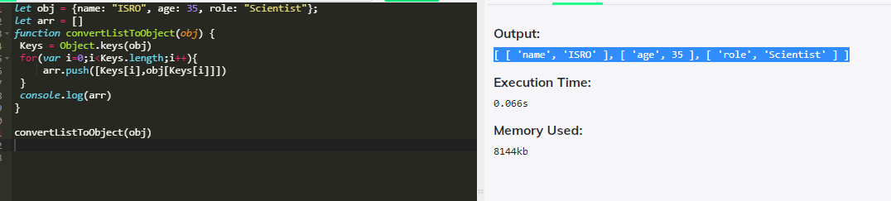

Problem 4( 5 mins):

Parsing a list and transform the first and last elements of it:
Write a function ‘transformFirstAndLast’ that takes in an array, and returns an object with:
1) the first element of the array as the object’s key, and
2) the last element of the array as that key’s value.
Input (Array):
var array = [“GUVI”, “I”, “am”, “Geek”];
Output:
var object = {
GUVI : “Geek”
}

Code:
var arr = ["GUVI", "I", "am", "a geek"];
function transformFirstAndLast(arr) {
newObject = {}
newObject[arr[0]] = arr[arr.length-1]
return newObject;
}

newObject = transformFirstAndLast(arr)
console.log(newObject)

Problem 5 ( 7 -9 mins):

Parsing a list of lists and convert into a JSON object:
Write a function “fromListToObject” which takes in an array of arrays, and returns an object with each pair of elements in the array as a key-value pair.
Input (Array):
var array = [[“make”, “Ford”], [“model”, “Mustang”], [“year”, 1964]];
Output:
var object = {
make : “Ford”
model : “Mustang”,
year : 1964
}

Code:
let arr = [["make", "Ford"], ["model", "Mustang"], ["year", 1964]];
function fromListToObject(arr) {
let newObject = {};
for(var i=0;i<arr.length;i++){
list = arr[i]
newObject[list[0]] = list[1]
}
return newObject;
}

newObject = fromListToObject(arr)
console.log(newObject)

Problem 6 (10 mins):

Parsing a list of lists and convert into a JSON object:
Write a function called “transformGeekData” that transforms some set of data from one format to another.
Input (Array):
var array = [[[“firstName”, “Vasanth”], [“lastName”, “Raja”], [“age”, 24], [“role”, “JSWizard”]], [[“firstName”, “Sri”], [“lastName”, “Devi”], [“age”, 28], [“role”, “Coder”]]];
Code:
let arr= [[["firstName", "Vasanth"], ["lastName", "Raja"], ["age", 24], ["role", "JSWizard"]], [["firstName", "Sri"], ["lastName", "Devi"], ["age", 28], ["role", "Coder"]]];
function transformEmployeeData(arr) {
let tranformEmployeeList = [];
for(let i=0;i<arr.length;i++){
let newObj = {}
for(let j=0;j<arr[i].length;j++){
newObj[arr[i][j][0]] = arr[i][j][1]
}
tranformEmployeeList.push(newObj)
}
return tranformEmployeeList;
}

tranformEmployeeList = transformEmployeeData(arr)
console.log(tranformEmployeeList)

Problem 7:

Parsing two JSON objects and Compare:
Read this : https://developer.mozilla.org/en-US/docs/Web/JavaScript/Reference/Global_Objects/JSON/stringify
Write an “assertObjectsEqual” function from scratch.
Assume that the objects in question contain only scalar values (i.e., simple values like strings or numbers).
It is OK to use JSON.stringify().
Note: The examples below represent different use cases for the same test. In practice, you should never have multiple tests with the same name.
Success Case:
Input:
var expected = {foo: 5, bar: 6};
var actual = {foo: 5, bar: 6}
assertObjectsEqual(actual, expected, ‘detects that two objects are equal’);
Output:
Passed
Failure Case:
Input:var expected = {foo: 6, bar: 5};
var actual = {foo: 5, bar: 6}
assertObjectsEqual(actual, expected, ‘detects that two objects are equal’);
Output:
FAILED [my test] Expected {“foo”:6,”bar”:5}, but got {“foo”:5,”bar”:6}

Code :

let expected = {foo: 5, bar: 7};
let actual = {foo: 5, bar: 7}
function assertObjectsEqual(actual, expected, testName="detects that two objects are equal"){
expected_Keys = Object.keys(expected)
for(let i=0;i<expected_Keys.length;i++){
if(expected[expected_Keys[i]] === actual[expected_Keys[i]]){
continue;
}else{
return "FAILED [my test] Expected "+ JSON.stringify(expected)+", but got"+JSON.stringify(actual)
}
}
return "SUCCESS"
}
//SUCCESS case
result = assertObjectsEqual(actual, expected)
console.log(result)

//Failure case
expected.foo = 7
result = assertObjectsEqual(actual, expected)
console.log(result)

Problem 8(10 mins):

Parsing JSON objects and Compare:
I have a mock data of security Questions and Answers. You function should take the object and a pair of strings and should return if the quest is present and if its valid answer

Code:

var securityQuestions = [
{
question: "What was your first pet’s name?",
expectedAnswer: "FlufferNutter"
},
{
question: "What was the model year of your first car?",
expectedAnswer: "1985"
},
{
question: "What city were you born in?",
expectedAnswer: "NYC"
}
]
function chksecurityQuestions(securityQuestions,question,ans) {
Arr = (securityQuestions.filter((item)=>(item.question == question && item.expectedAnswer == ans)));
//console.log(Arr);
return (Arr.length === 1) ? true : false
}
//Test case1:
var ques = "What was your first pet’s name?";
var ans = "FlufferNutter";
var status = chksecurityQuestions(securityQuestions, ques, ans);
console.log(status); // true
//Test case2:
var ques = "What was your first pet’s name?";
var ans = "DufferNutter";
var status = chksecurityQuestions(securityQuestions, ques, ans);
console.log(status); // false

Output:

Problem 9(20 mins):

Parsing JSON objects and Compare:
Write a function to return the list of characters below 20 age
Code:
var students = [{ name: "Siddharth Abhimanyu", age: 21}, { name: "Malar", age: 25},
{name: "Maari",age: 18},{name: "Bhallala Deva",age: 17},
{name: "Baahubali",age: 16},{name: "AAK chandran",age: 23}, {name:"Gabbar Singh",age: 33},{name: "Mogambo",age: 53},
{name: "Munnabhai",age: 40},{name: "Sher Khan",age: 20},
{name: "Chulbul Pandey",age: 19},{name: "Anthony",age: 28},
{name: "Devdas",age: 56}
];

function returnMinors(arr)
{
return students.filter((value)=> value.age<20)
}
output = returnMinors(students);
output.forEach((a)=>console.log(a.name))

